Aditya Patel

APUSH

Period 4

10/15/2020

Presentation: Jackson, Democracy and The Spoils System

**Secondary Source:**

**Andrew Jackson: Domestic Affairs**

Daniel Feller, Professor of History from the University of Tennessee

https://millercenter.org/president/jackson/domestic-affairs

Jackson entered the White House with an uncertain policy agenda beyond a vague craving for "reform" (or revenge) and a determination to settle relationships between the states and the Indian tribes within their borders. On these two matters he moved quickly and decisively.

During the campaign, Jackson had charged the Adams bureaucracy with fraud and with working against his election. As President, he initiated sweeping removals among highranking government officials—Washington bureau chiefs, land and customs officers, and federal marshals and attorneys. Jackson claimed to be purging the corruption, laxity, and arrogance that came with long tenure, and restoring the opportunity for government service to the citizenry at large through "rotation in office." But haste and gullibility did much to confuse his purpose.

Under the guise of reform, many offices were doled out as rewards for political services. Newspaper editors who had championed Jackson's cause, some of them very unsavory characters, came in for special favor. His most appalling appointee was an old army comrade and political sycophant named Samuel Swartwout. Against all advice, Jackson made him collector of the New York City customhouse, where the government collected nearly half its annual revenue. In 1838, Swartwout absconded with more than $1 million, a staggering sum for that day. Jackson denied that political criteria motivated his appointments, claiming honesty and efficiency as his only goals. Yet he accepted an officeholder's support for Adams as evidence of unfitness, and in choosing replacements he relied exclusively on recommendations from his own partisans. A Jackson senator from New York, William L. Marcy, defended Jackson's removals by proclaiming frankly in 1832 that in politics as in war, "to the victor belong the spoils of the enemy." Jackson was never so candid—or so cynical. Creating the "spoils system" of partisan manipulation of the patronage was not his conscious intention. Still, it was his doing.

**The Eaton Affair**

Jackson was already becoming estranged from Calhoun over a simmering Washington scandal. Jackson's secretary of war, John Henry Eaton, was an old army comrade, Jackson's his campaign biographer, and a Tennessee neighbor. He was the President's one personal confidante in a cabinet made up of near-strangers. Just before the inauguration, Eaton had married Margaret O'Neale Timberlake, the vivacious daughter of a Washington hotelier. Scandalous stories circulated about "Peggy" O'Neale, whose first husband, a purser in the Navy, had died abroad under mysterious circumstances not long before her marriage to Eaton. Rumor said that he committed suicide over her dalliance with Eaton. Cabinet wives, including Calhoun's wife Floride, regarded Peggy with abhorrence and conspicuously shunned her.

In the snubbing of Mrs. Eaton, Jackson saw the kind of vicious persecution that he believed had hounded his own Rachel to her death. He also believed he spied a plot to drive out Eaton from his cabinet, isolate him among strangers, and control his administration. The master of the plot, Jackson came to decide, was Calhoun. He was also shown evidence that during the controversy over his Florida incursion back in 1818, Calhoun had criticized him in Monroe's cabinet while publicly posturing as his defender. Jackson now accused Calhoun of treachery, initiating an angry correspondence that ended with the severing of social relations between the two.

The Eaton scandal cleaved Jackson's own household. His niece, White House hostess Emily Tennessee Donelson, refused to associate with Mrs. Eaton, and Emily's husband, Jackson's nephew and private secretary Andrew Jackson Donelson, backed her up. The one cabinet officer who stood apart from the snubbing was a man with no wife to contend with—Secretary of State Martin Van Buren of New York, a widower. Jackson was drawn to Van Buren both by his courtliness to Peggy Eaton and his policy views. Van Buren wished to return to the minimalist, strict constructionist governing philosophy of the old Jeffersonian party. In practical political terms, he sought to rebuild the coalition of "planters and plain republicans"—put concretely, an alliance of the South with New York and Pennsylvania—that had sustained Jefferson. Van Buren opposed the American System, but on broad philosophical rather than narrow sectional grounds.

As Jackson separated from Calhoun, he became more intimate with Van Buren. By 1831, the Eaton imbroglio threatened to paralyze the administration. Eaton and Van Buren created a way out: they resigned, giving Jackson an occasion to demand the resignations of the other secretaries and appoint a whole new cabinet. To reward Van Buren, Jackson named him as minister to Great Britain, the highest post in the American diplomatic service. The nomination came before the Senate, where Vice-President Calhoun, on an arranged tie vote, cast the deciding vote against it. Van Buren, who had already assumed his station abroad, came home as a political martyr, Jackson's choice for vice-president in 1832, and his heir apparent to the presidency.

**The Nullification Crisis and the Compromise of 1833**

As Van Buren rose and Calhoun fell, the tariff controversy mounted to a crisis. Congress passed a new tariff in 1832 that reduced some rates but continued the protectionist principle. Some Southerners claimed this as a sign of progress, but South Carolinians saw it as reason to abandon hope in Washington. In November, a state convention declared the tariff unconstitutional and hence null and void. South Carolina's legislature followed up with measures to block the collection of federal custom revenues at the state's ports and to defend the state with arms against federal incursion.

Jackson responded on two fronts. He urged Congress to reduce the tariff further, but he also asked for strengthened authority to enforce the revenue laws. Privately, and perhaps for calculated political effect, he talked about marching an army into South Carolina and hanging Calhoun. In December, he issued a ringing official proclamation against nullification. Drafted largely by Secretary of State Edward Livingston, the document questioned Carolinians' obsession with the tariff, reminded them of their patriotic heritage, eviscerated the constitutional theory behind nullification, and warned against taking this fatal step: "Be not deceived by names. Disunion by armed force is treason. Are you really ready to incur its guilt?"While Jackson thundered, Congress scrambled for a solution that would avoid civil war. Henry Clay, leader of the congressional opposition to Jackson and stalwart of the American System, joined in odd alliance with John C. Calhoun, who had resigned his lame-duck vice-presidency for a seat in the Senate. They fashioned a bill to reduce the tariff in a series of stages over nine years. Early in 1833, Congress passed this Compromise Tariff and also a "force bill" to enforce the revenue laws. Though the Clay-Calhoun forces sought to deny Jackson credit for the settlement, he was fully satisfied with the result. South Carolina, claiming victory, rescinded its nullification of the tariff but nullified the force bill in a final gesture of principled defiance. The Compromise of 1833 brought an end to tariff agitation until the 1840s. First with internal improvements, then with the tariff, the American System had been essentially stymied.

**The Bank Veto**

The congressional Clay-Calhoun alliance foreshadowed a convergence of all Jackson's enemies into a new opposition party. The issue that sealed this coalition, solidified Jackson's own following, and dominated his second term as President was the Second Bank of the United States.

The Bank of the United States was a quasi-public corporation chartered by Congress to manage the federal government's finances and provide a sound national currency. Headquartered in Philadelphia with branches throughout the states, it was the country's only truly national financial institution. The federal government owned one-fifth of the stock and the President of the United States appointed one-fifth of the directors. Like other banks chartered by state legislatures, the Bank lent for profit and issued paper currency backed by specie reserves. Its notes were federal legal tender. By law, it was also the federal government's own banker, arranging its loans and storing, transferring, and disbursing its funds. The Bank's national reach and official status gave it enormous leverage over the state banks and over the country's supply of money and credit.

The original Bank of the United States was chartered in 1791 at the urging of Secretary of the Treasury Alexander Hamilton. Opposition to it was one of the founding tenets of the Jeffersonian Democratic-Republican party. That party allowed the Bank to expire when its twenty-year charter ran out in 1811. But the government's financial misadventures in the War of 1812 forced a reconsideration. In 1816, Congress chartered the Second Bank, again for twenty years.

Imprudent lending and corrupt management brought the Second Bank into deep disrepute during the speculative boom-and-bust cycle that culminated in the Panic of 1819. Calls arose for revocation of the charter. But the astute stewardship of new Bank president Nicholas Biddle did much to repair its reputation in the 1820s. By 1828, when Jackson was first elected, the Bank had ceased to be controversial. Indeed, most informed observers deemed it indispensable.

Startling his own supporters, Jackson attacked the Bank in his very first message to Congress in 1829. Biddle attempted to conciliate him, but Jackson's opposition to renewing the charter seemed immovable. He was convinced that the Bank was not only unconstitutional—as Jefferson and his followers had long maintained—but that its concentrated financial power represented a dire threat to popular liberty.

Under the advice of Senators Henry Clay and Daniel Webster, Biddle sought a congressional recharter in 1832. They calculated that Jackson would not dare issue a veto on the eve of the election; if he did, they would make an issue of it in the campaign. The recharter bill duly passed Congress and on July 10, Jackson vetoed it.

The veto message was one of the defining documents of Jackson's presidency. Clearly intended for the public eye, parts of it read more like a political manifesto than a communication to Congress. Jackson recited his constitutional objections and introduced some dubious economic arguments, chiefly aimed at foreign ownership of Bank stock. But the crux of the message was its attack on the special privilege enjoyed by private stockholders in a government-chartered corporation. Jackson laid out an essentially laissez-faire vision of government as a neutral arbiter, phrased in a resonant populism:"It is to be regretted that the rich and powerful too often bend the acts of government to their selfish purposes. Distinctions in society will always exist under every just government. Equality of talents, of education, or of wealth can not be produced by human institutions. In the full enjoyment of the gifts of Heaven and the fruits of superior industry, economy, and virtue, every man is equally entitled to protection by law; but when the laws undertake to add to these natural and just advantages artificial distinctions, to grant titles, gratuities, and exclusive privileges, to make the rich richer and the potent more powerful, the humble members of society—the farmers, mechanics, and laborers--who have neither the time nor the means of securing like favors to themselves, have a right to complain of the injustice of their Government. There are no necessary evils in government. Its evils exist only in its abuses. If it would confine itself to equal protection, and, as Heaven does its rains, shower its favors alike on the high and the low, the rich and the poor, it would be an unqualified blessing."

Though some original Jackson men were flabbergasted and outraged at his turn against the Bank, the veto held up in Congress. It became the prime issue in the ensuing presidential campaign, with both sides distributing copies of Jackson's message. Jackson read his re-election as a mandate to pursue his attack on the Bank further.

**Removal of the Deposits**

As soon as the nullification crisis was resolved, Jackson took his next step. The Bank's open involvement in the presidential campaign convinced him more than ever of its inherent corruption. To draw its fangs until its charter ran out in 1836, he determined to withdraw the federal government's own deposits from the Bank and place them in selected state-chartered banks.

This was a maneuver requiring some delicacy. Under the charter, the secretary of the treasury, not the President, had authority to remove the deposits. He had also to explain his reasons to Congress, where the House of Representatives had just voted by a two-to-one margin that the deposits should stay where they were. Jackson canvassed his cabinet on removal. Most of them opposed it, but he got the support and arguments he needed from Attorney General Roger Taney. Jackson drew up a paper explaining his decision, read it to the cabinet, and ordered Treasury Secretary William John Duane to execute the removal. To Jackson's astonishment, Duane refused. He also refused to resign, so Jackson fired him and put Taney in his place. Taney ordered the removal, which was largely complete by the time Congress convened in December 1833.

Even many congressional foes of the Bank could not countenance Jackson's proceedings against it. He had defied Congress's intent, rode roughshod over the treasury secretary's statutory control over the public purse, and removed the public funds from the lawfully authorized, responsible hands of the Bank of the United States to an untried, unregulated, and perhaps wholly irresponsible collection of state banks. To many, Jackson seemed to regard himself as above the law.

Fortunately for Jackson, Bank president Nicholas Biddle over-reacted and played into his hands. Regarding the removal of deposits as a declaration of open war, Biddle determined to force a recharter by creating a financial panic. Loss of the deposits required some curtailment of the Bank's loans, but Biddle carried the contraction further than was necessary in a deliberate effort to squeeze businessmen into demanding a recharter. This manipulation of credit for political ends served only to discredit the Bank and to vindicate Jackson's strictures against it.

Congress did not even consider recharter, but it did lash out at Jackson. Clay men and Southern anti-tariffites could not agree on the American System; they could not all agree on rechartering the Bank; but they could unite in their outrage at Jackson's high-handed proceedings against it. In the 1833-1834 session, Jackson's congressional foes converged to form a new party. They took the name of Whigs, borrowed from Revolutionary-era American and British opponents of royal prerogative.

Whigs held a majority in the Senate. They rejected Jackson's nominees for government directors of the Bank of the United States, rejected Taney as secretary of the treasury, and in March 1834, adopted a resolution of censure against Jackson himself for assuming "authority and power not conferred by the Constitution and laws, but in derogation of both." Jackson protested the censure, arguing that the Senate had adopted the moral equivalent of an impeachment conviction without formal charges, without a trial, and without the necessary two-thirds vote. Led by Thomas Hart Benton, Jackson's defenders mounted a crusade to expunge the censure from the Senate journal. They succeeded in 1837, at the end of Jackson's presidency, after Democrats finally won majority control of the Senate.

**Primary Source:**

**Forty Years of American Life**

Nichols, Thomas Low, 1815-1901

When the four years of Mr. Adams were over, General Jackson was elected President. I remember well the excitement of the contest. The Adams, Federalist, or National Republican party, as it was called, charged General Jackson with every crime, including half-a-dozen murders. They issued hand-bills, ornamented with coffins, called “coffin hand-bills,” which related the stories of the hanging of the two Englishmen in Florida, and several other persons. The Jackson, or Democratic party, took the bull by the horns, and multiplied the handbills, to show how their candidate was abused. It was found that hanging a couple of Englishmen was not an element of unpopularity. He had killed some hundreds at New Orleans. As the canvass went on, his popularity increased. Hickory trees were raised in every village—the land rang with the Hunters of Kentucky. The Federalist, or what would here be the High-Tory antecedents of Adams, the son of John Adams, second President, and father of Mr. Lincoln's ambassador to England, were against him—so was the “bribery and corruption” story. Jackson was elected by a triumphant majority. The party of Jefferson and Madison was restored to power; a clean sweep was made in nearly all offices under Government, from cabinet ministers to village post-masters and tide-waiters. At the end of four years an attempt was made to elect Mr. Clay, but Jackson was too popular. He was re-elected in 1832 by an increased majority. Jackson was a type of the Southern American. Brave to rashness, generous to prodigality, a firm and trusting friend, a relentless foe, he had the qualities which make a popular leader. He had the magnetism of command, a powerful will, and indomitable firmness. No American leader ever had more devoted partisans. Seldom has the chief of a party won to so great a degree the respect and admiration of his opponents. Living on a plantation—The Hermitage—near Nashville, Tennessee, he was beloved by his neighbours and almost adored by his slaves, who looked up to him as to a superior being. He married a lady who had been separated from her husband, and loved her to her death with a chivalric devotion. He did not hesitate to challenge and kill the man who spoke slightingly of his wife. After she died, her picture was beside his pillow. There was a fierce tenderness in his love. Like Washington, Jefferson, and Madison, three preceding Presidents, he left no son to bear his name. Jefferson had a daughter, and a numerous posterity. Jackson had no children.

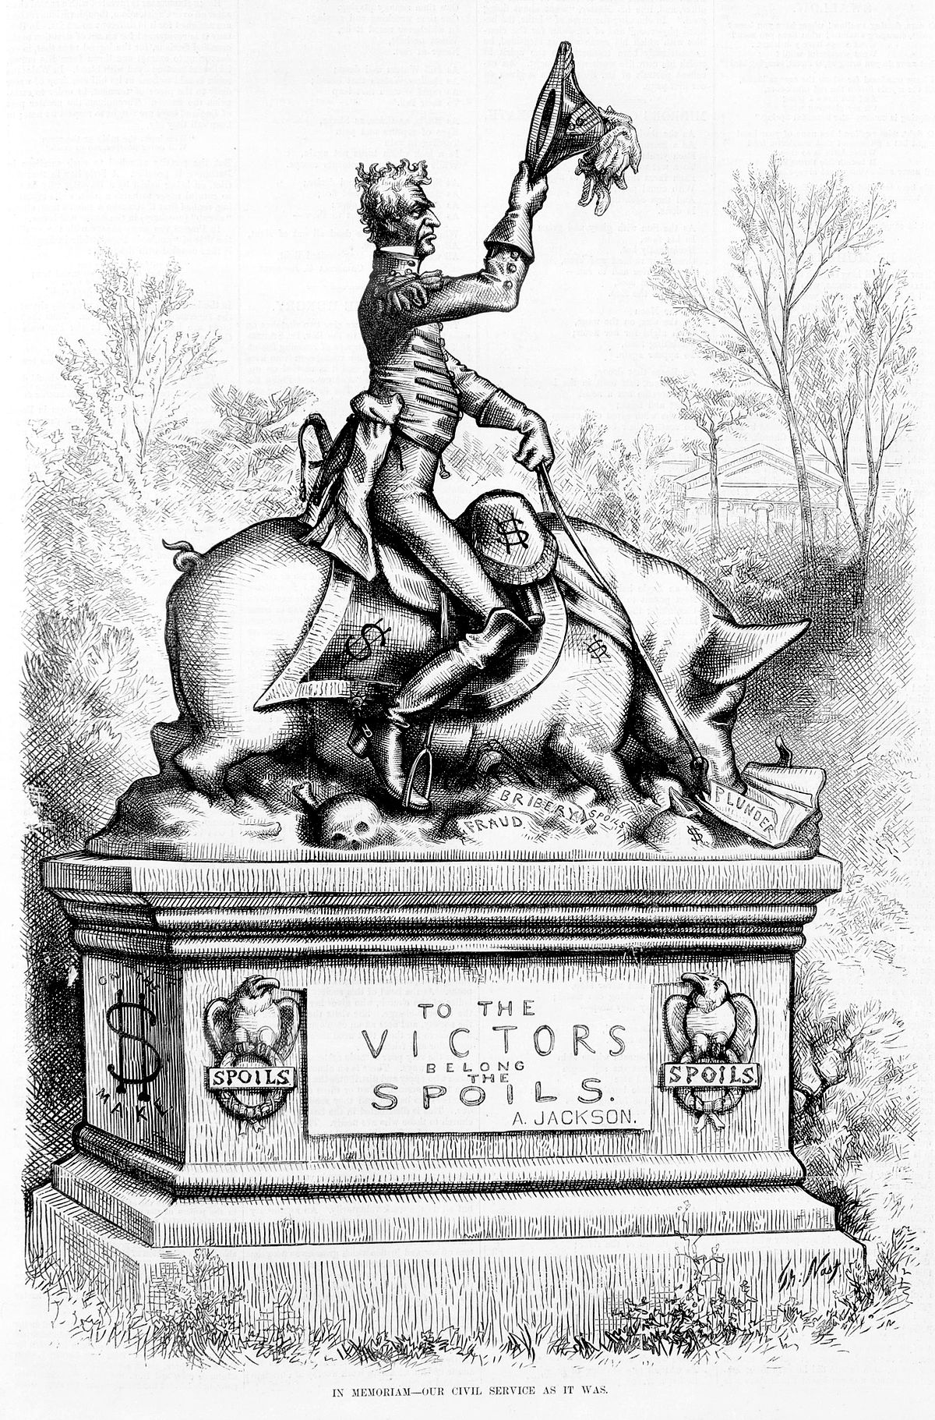

By Thomas Nast, depicting Jackson’s administration as corrupt and tyrannical.

Other Sources:

<https://millercenter.org/president/jackson/life-before-the-presidency>

https://s-usih.org/2017/06/a-stupidity-which-has-excited-the-wonder-of-mankind-andrew-jackson-and-the-historians/